1st Mission Report

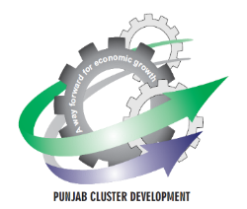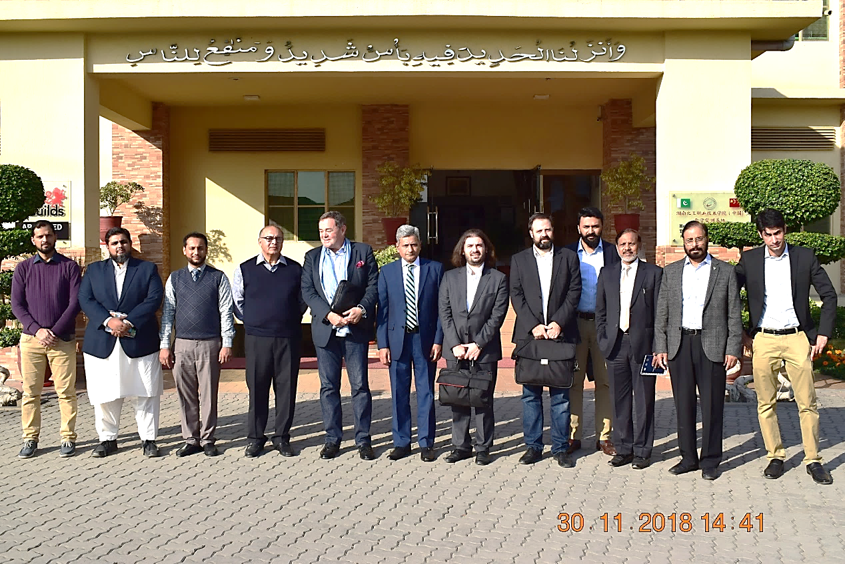

**1st Competitive Reinforcement Initiative (CRI) of Auto Parts Cluster – Lahore**

**“Operationalization of Auto Parts Support Centre”**

**November 21 – 30, 2018**

**The CDI is jointly implemented by PSIC and UNIDO**

Cluster Development Initiative

A way forward for Economic Growth

**Table of Contents**

1. Operationalization of Auto Parts Support Centre (APSC) 2

2. Engagement of International Experts 2

3. Prior Mission Activities 3

4. Kick Off Mission of International Experts 3

4.1.1 Meeting with Original Equipment Manufacturers (OEMs) 3

4.1.2 Meeting with Vendors 4

4.1.3 Meeting with Government Officials 4

4.1.4 Meetings with Pakistan Association of Automotive Parts and Accessories Manufacturers (PAAPAM) 4

4.1.5 Visit of Auto Parts Support Centre (APSC) 5

4.1.6 Meeting with Legal Entities 5

5. Way Forward 5

# Operationalization of Auto Parts Support Centre (APSC)

The Auto Parts Cluster team of Cluster Development Initiative (CDI) project carried out Diagnostic Study (DS) of Auto Parts cluster, Lahore with technical assistance of United Nations Industrial Development Organization (UNIDO). In light of the findings of the DSR, 1st pilot Competitive Reinforcement Initiative (CRI) on “Operationalization of Auto Parts Support Centre” was identified in consultation with Pakistan Association of Automotive Parts and accessories manufacturers (PAAPAM). The project was approved by Cluster Project Selection Committee of the CDI Project in its meeting held on January 30, 2018 with a total cost of PKR. 10.963 million and gestation period of 12 months. The objective of the CRI is to prepare a viable Business Model for Operationalization of Auto Parts Support Center-APSC.

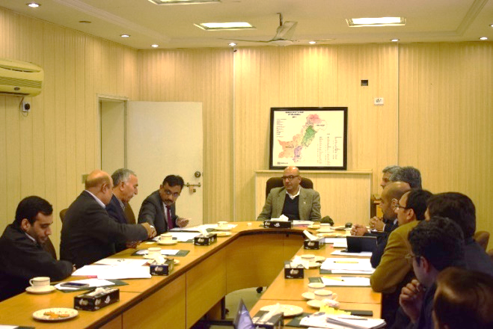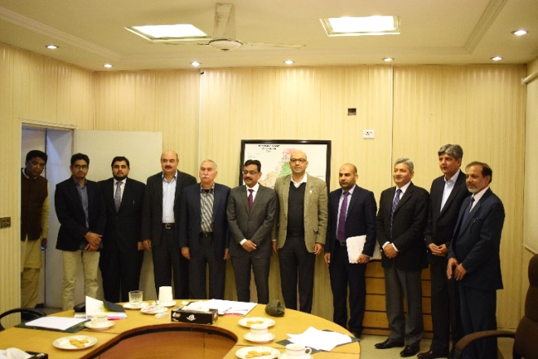

**Secretary Industries presiding over the Meeting of Cluster Project Selection Committee**

# Engagement of International Experts

UNIDO engaged Int’l Experts to assess the needs of the auto parts cluster in order to develop services portfolio and Business Plan for the APSC. The credentials of the Int’l experts (Mr. Thorstensen Truls, Mr. Alan Bryant, and Mr. Eylem Can Cetintas) were shared with PSIC and PAAPAM through CDI prior to the approval from MD, PSIC.



Mr. Thorstensen Truls Mr. Alan Bryant Mr. Eylem Can Cetintas

(Mission Leader)

# Prior Mission Activities

Prior to the mission, Auto Parts Cluster team carried out close liaison with relevant stakeholders of the cluster including OEMs (Honda Atlas Cars, Hyundai Nishat Motors, Al-Futtaim Automotive Pakistan (Renault), PAAPAM and auto parts manufacturers. The aim of this coordination was to collect the relevant information for the Int’l Experts, facilitating their mission objective. The mission schedule for the Int’l Experts is attached as **(Annex –I).**

# Kick Off Mission of International Experts

To initiate the activities concerning implementation of 1st pilot CRI in auto parts cluster, Lahore, the kick off mission of UNIDO’s international experts was planned from 21st November, 2018 to 30th November, 2018. The mission leader Mr. Truls arrived Lahore on 21st November, 2018 and held his introductory meetings with car OEMs and Government Officials and explained his mission objectives to them. The technical experts of the mission team arrived on 26th November, 2018 and in consultation with Original Equipment Manufacturers (OEMs) and vendors collected necessary data for devising viable business model of the APSC. The objective of the kick off mission was to:

* General Assessment of the Autoparts Cluster and identification of development opportunities
* Need assessment of the autoparts cluster to develop demand driven service portfolio of the APSC.
* Development of Business Plan for operationalization of APSC

# Meeting with Original Equipment Manufacturers (OEMs)

The UNIDO’s Int’l and National Experts along with Project Director CDI auto parts cluster team held meetings with OEMs including two sessions with Honda Atlas Cars (Pakistan) Limited and Hyundai Nishat Motors, whereas one meeting was held with Al-Futtaim Automotive Pakistan (Renault) and Omega Industries. The management of these OEMs intimated that the automotive industry does not have quality dies and molds manufacturing facility in Lahore.

The localization plan of Honda Atlas Cars discussed in detail in the meetings. Honda management apprised that 68% localization of car components had been achieved. Further localization has been hampered due to lack of innovative capacity of the local vendor industry, duty structure on semi-finished and finished components, low volumes for amortization, etc. The upcoming OEMs shared their overall strategy to operationalize their plants in Pakistan vis-à-vis potential localization scenarios. They intimated that automotive sector is likely to grow at7%~8% annually for the next five years thereby providing substantial business expansion opportunities to the existing automobile vendor industry.

# Meeting with Vendors

The mission visited two vendor firms to discuss and understand their current production capacities along with their export market orientation and future development aspirations. In addition, two consultative sessions were held with vendors of cars and motorcycles auto parts manufacturers at PAAPAM on 28th and 29th November, 2018, respectively. The purpose of these sessions was to identify existing capabilities of the auto vendor industry in terms of their current technology level, preparedness to meet future demands of the OEMs and export market, and prevailing human resource competencies. Meaningful insights were obtained as to the potential institutional role of APSC in the overall development of the autoparts cluster.

# Meeting with Government Officials

Meetings with MD PSIC, Secretary IC & ID and Secretary P&D Government of Punjab were held to discuss the objectives of the CRI and purpose of the mission.. UNIDO’s Int’l Experts highlighted the activities they will be carrying out during the mission to realize the objectives of the CRI. The Government officials ensured high level of commitment and support to the Int’l Experts and appreciated their approach to take on board all the relevant stakeholders to develop a sound business plan for the operationalization of APSC. .

# Meetings with Pakistan Association of Automotive Parts and Accessories Manufacturers (PAAPAM)

Three meetings of the mission were held with PAAPAM to discuss the needs of the cluster and accordingly to corroborate the service portfolio and operationalization strategy of the APSC. PAAPAM nominated three members’ committee to finalize the partnership model and list of potential services of APSC.

As a result of detailed deliberations with PAAPAM, it has been decided that the Int’l Experts will prepare a general assessment report of the cluster identifying potential development opportunities catering the domestic and export market requirements. And keeping in view the “**OEM-Vendor value chain model”** they will identify the prevailing technological, HR and material and product testing gaps and will develop service portfolio of the APSC. Based on the inputs from PAAPAM and consultations with legal bodies they will draft and present a business plan for the APSC to all the relevant stakeholders in their upcoming mission. PAAPAM not only consented with this approach but also provided inputs on prevailing partnership models such as Section 42 company, Private Limited company and Public-Private Partnership Models. PAAPAM emphasized on the management contract model that comes under the Public-Private Partnership Act 2014 of Punjab. Additionally, the Int’l Experts also floated the idea to identify joint venture opportunities so as to conduit int’l expertise for the development of innovative capacity of the vendor industry through APSC.

# Visit of Auto Parts Support Centre (APSC)

The mission team visited APSC located at Kot Lakhpat Industrial Estate, Lahore and physically examined the workability of existing machinery. They discussed the HR details and the market demand of the services of the center with the Regional Director, Lahore, PSIC.

# Meeting with Legal Entities

The Int’l Experts held meetings with Agha Waqar Javed, Member (PPP) P&D Board, and legal advisors (Rizvi & Rizvi Associates) to assess the available partnership models for the operationalization of the center. In view of these consultations the Int’l Experts will include various partnership/company options in the business plan.

# Way Forward

The deliverables of this mission will be as under:

* A general assessment report of the autoparts cluster in Lahore identifying cluster development opportunities from short to medium and long term
* Service portfolio of APSC bridging the service gaps between existing vendor industry and OEMs future demands
* Draft template of Business Plan for operationalization of APSC with initial inputs included

**Picture Gallery**

|  |  |
| --- | --- |
| **Meetings with OEMs** | |
| Meeting with Honda Atlas Cars | Group photo at Honda Atlas Cars |
| Meeting with Hyundai Nishat Motors | Meeting with Al-Futtaim Automotive Pakistan (Renault) |
| Meeting with Road Prince (Omega Industries) | |

|  |  |
| --- | --- |
| **Meetings with APMs** | |
| Meeting at Novelty Engineering | Meeting at Infinity Engineering |
| Meeting at Risan Synthetic Technic | |
| **Opening Meeting with PAAPAM** | |
| Opening Meeting with PAAPAM | |

|  |  |
| --- | --- |
| **Consultative Session with Car Parts Manufacturers** | |
|  |  |
|  |  |
| **Consultative Session with Motorcycle Parts Manufacturers** | |
|  |  |
|  |  |

|  |  |
| --- | --- |
| **Meeting with PPP Cell** | |
| Meeting with top management of PPP Cell | |
| **Wrap Up Meeting with PAAPAM** | |
|  |  |